Chapter 9, Solution 68.

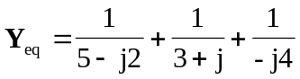

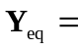 (472.4 + j219) mS

